

**DETAIL DESIGN DOCUMENT**

**IVOLUNTEER**

**Screen Design**

**Project Code: IVSN**

**Document Code: IVSN_ScreenDesign_v1.0_EN**

**Hanoi, Jun 02nd 2016**

# SIGNATURE PAGE

|  |  |  |
| --- | --- | --- |
| AUTHOR: | Võ Tôn Phúc  Team Member | 02/06/2016 |
| REVIEWERS: | Nguyễn Mình Đức  Project Manager | xx/06/2016 |
| APPROVAL: | Bùi Đình Chiến  Supervior |  |

# RECORD OF CHANGE

*A - Added M - Modified D – Deleted

|  |  |  |  |  |  |
| --- | --- | --- | --- | --- | --- |
| **Effective Date** | **Changed Item** | **A,M,D** | **Change Description** | **Reason for Change** | **Rev. Number** |
| 02/06/2016 | Create Screen Design | A |  |  | 1.0 |
|  |  |  |  |  |  |
|  |  |  |  |  |  |

Contents

SIGNATURE PAGE 2

RECORD OF CHANGE 3

1 INTRODUCTION 5

1.1 Purpose 5

1.2 Definition, Acronyms and Abbreviations 5

2 SCREEN FLOW 6

2.1 Registration 7

2.2 Authentication 9

2.3 Home page 10

2.4 Profile 14

2.5 Project 17

2.6 Search 20

# INTRODUCTION

## Purpose

## Definition, Acronyms and Abbreviations

|  |  |  |
| --- | --- | --- |
| Abbreviations | Description | Comment |
| IVSN | iVolunteer Social Network |  |
| Q&A | Question and answer |  |

*Table 1-1: 1.2 Definition, Acronyms and Abbreviations*

# SCREEN FLOW



*Figure 2-1: Screen structure or transition between screens*

## Registration

### Registration step 1

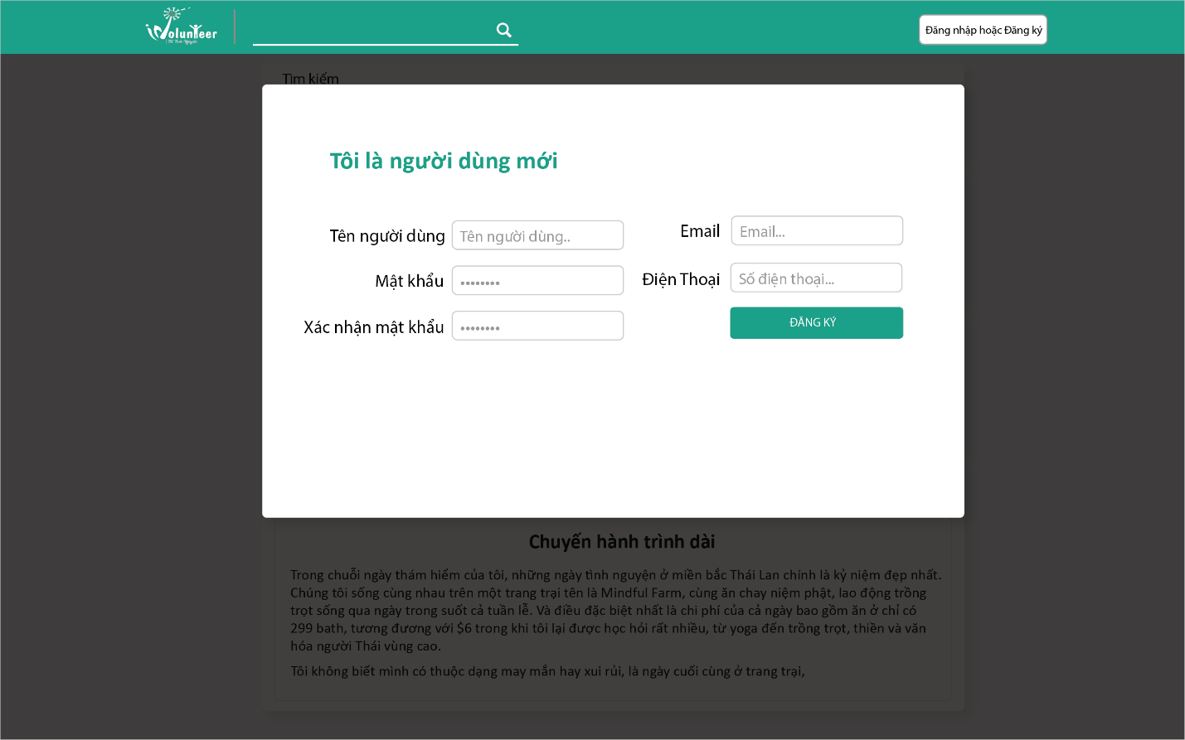

Figure ‑

|  |  |  |  |  |  |  |  |
| --- | --- | --- | --- | --- | --- | --- | --- |
| No | Field name | Field name in Vietnamese | Type | Require | Mandatory | Max-Length | Description |
| 1 | New User | Tôi là người dùng mới | Label |  | Y |  | Display registration step 1 title |
| 2 | User name | Tên người dùng | Label |  | Y |  | Display user name label |
| 3 | User name |  | Text box | Type | Y |  | Get user name |
| 4 | Password | Mật khẩu | Label |  | Y |  | Display password label |
| 5 | Password |  | Text box | Type | Y |  | Get password |
| 6 | Re-enter password | Xác nhận mật khẩu | Label |  | Y |  | Display re-enter password label |
| 7 | Re-enter password |  | Text box | Type | Y |  | Get re-enter password |
| 8 | Email | Email | Text |  | Y |  | Display email label |
| 9 | Email |  | Text box | Type | Y |  | Get email address |
| 10 | Phone number | Số điện thoại | Label |  | Y |  | Display phone number label |
| 11 | Phone number |  | Text box | Type | Y |  | Get phone number |
|  | Register | Đăng kí | Button | Click | Y |  |  |

Table ‑

### Registration step 2

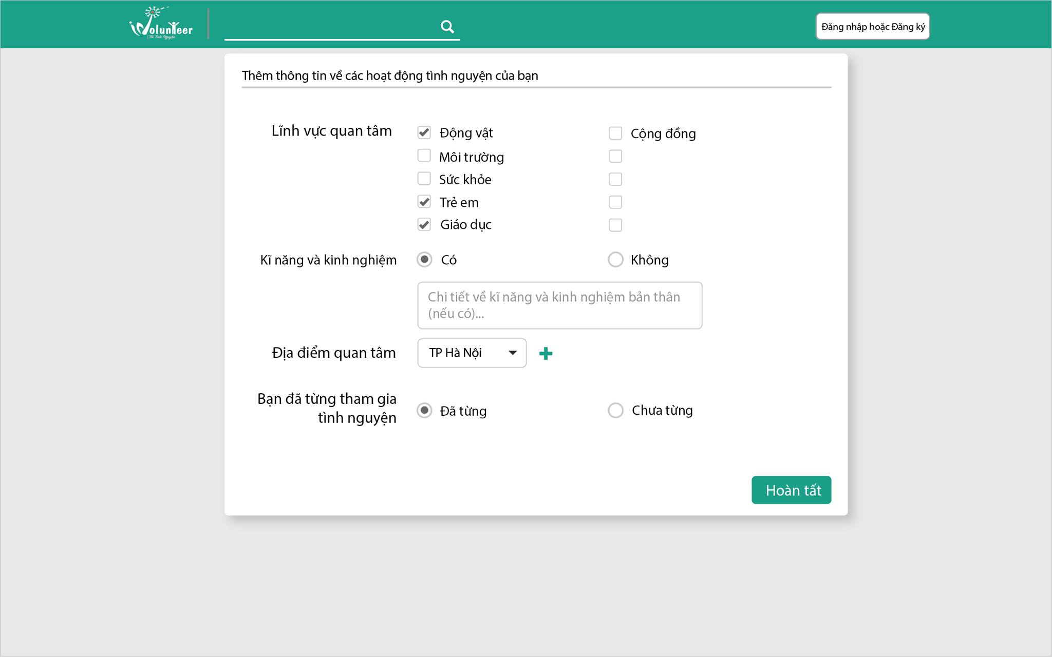

Figure ‑

|  |  |  |  |  |  |  |  |
| --- | --- | --- | --- | --- | --- | --- | --- |
| No | Field name | Field name in Vietnamese | Type | Require | Mandatory | Max-Length | Description |
| 1 | Volunteering information | Thêm thông tin về các hoạt động tình nguyện của bạn | Label |  | Y |  | Registration step 2 label |
| 2 | Favorite sector | Lĩnh vực quan tâm | Label |  | Y |  | Favorite sector label |
| 4 | Favorite sector |  | Checkbox list | Click | Y |  | Get favorite sector items.  Favorite sector item names include: “Động vật”, ”Môi Trường”,”Sức khỏe”,”Trẻ em”, “Giáo dục”, “Cộng đồng”. |
| 5 | Experience | Kỹ năng kinh nghiệm | Label |  | Y |  | Experience label. |
| 6 | Experience |  | Multiple choice list | Click | Y |  | Multiple choice list includes “Co”, “Khong”. |
| 7 | Experience |  | Text box | Type | Y |  | Get text value in experience text box. |

Table ‑

## Authentication

### Log in

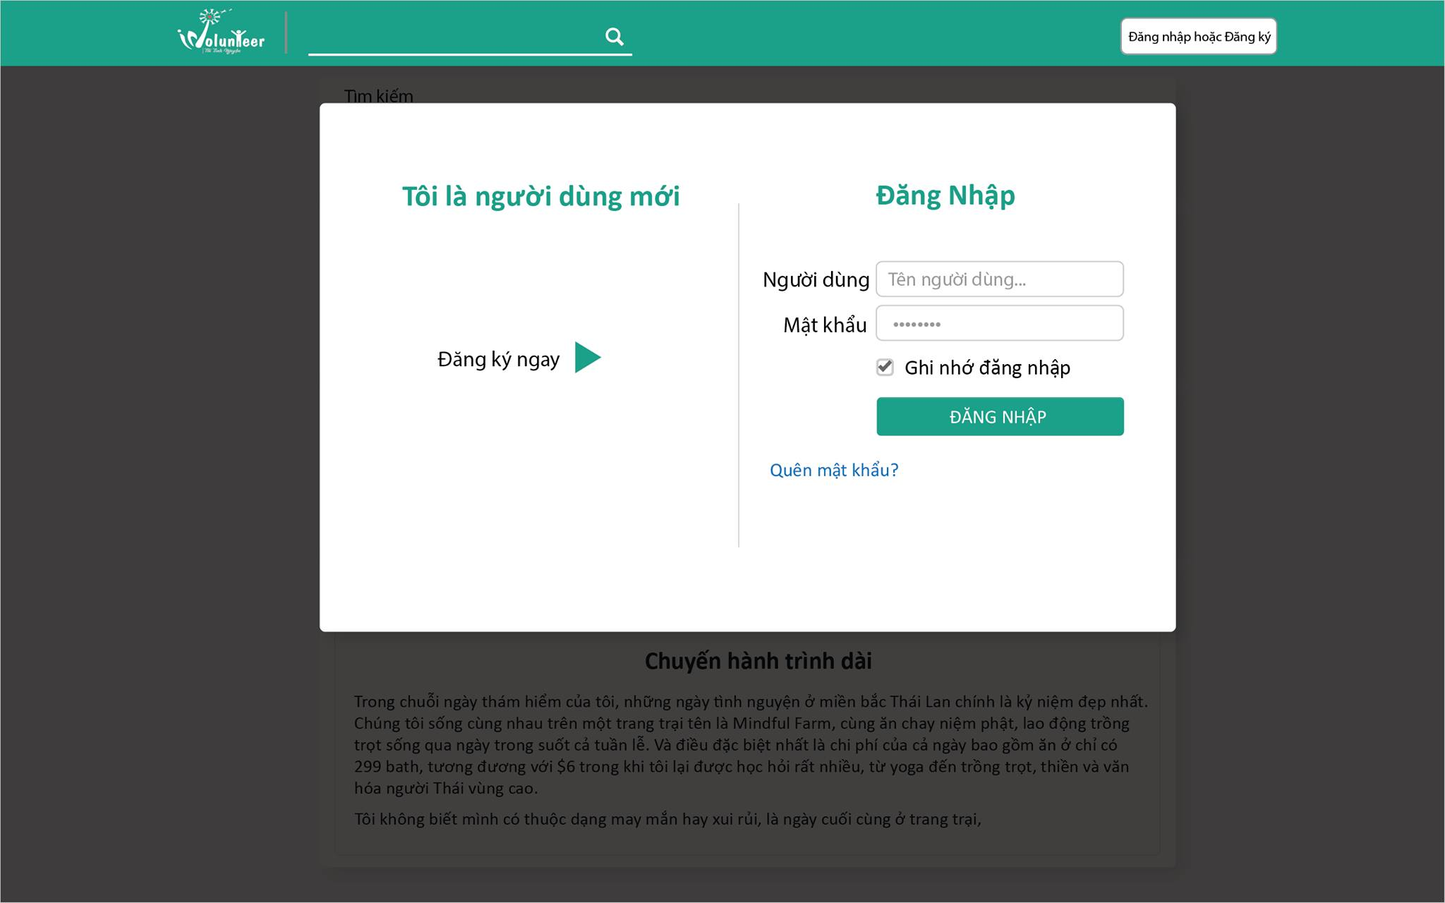

Figure ‑

|  |  |  |  |  |  |  |  |
| --- | --- | --- | --- | --- | --- | --- | --- |
| No | Field name | Field name in Vietnamese | Type | Require | Mandatory | Max-Length | Description |
| 1 | New user | Tôi là người dùng mới | Label |  | Y |  |  |
| 2 | Register | Đăng kí ngay | Button | Click | Y |  | Click to display registration form |
| 3 | Log in | Đăng nhập | Label |  | Y |  |  |
| 4 | User name | Tên người dùng | Label |  | Y |  |  |
| 5 | User name | Tên người dùng | Text box | Type | Y |  | Get user name value. |
| 6 | Password | Mật khẩu | Label |  | Y |  |  |
| 7 | Password | Mật khẩu | Text box | Type | Y |  | Get password value |
| 8 | Remember me | Ghi nhớ đăng nhập | Checkbox | Click | Y |  | Get if user checked the box. |
| 9 | Login | Đăng nhập | Button | Click | Y |  | Click to log in into the system |
| 10 | Forgot password | Quên mật khẩu | Link | Click | Y |  | Click to open Forgot password form. |

Table ‑

### Forgot Password

### Reset Password

## Home page

### Home page for guest

### https://scontent-hkg3-1.xx.fbcdn.net/v/t35.0-12/13340729_908409979267609_529962374_o.png?oh=5d2bfb5ce912f07e0444bfc7401ff134&oe=57558638

Figure ‑

|  |  |  |  |  |  |  |  |
| --- | --- | --- | --- | --- | --- | --- | --- |
| No | Field name | Field name in Vietnamese | Type | Require | Mandatory | Max-Length | Description |
| Navigation bar | | | | | | | |
| **1** | iVolunteer | Tôi tình nguyện | Link | Click | Y |  | Click to return to Home page. |
| **2** | Search |  | Text box | Type | Y |  | Get search value |
| **3** | Search |  | Button | Click | Y |  | Click to open Search Result page |
| **4** | Login or Register | Đăng nhập hoặc đăng kí | Button | Click | Y |  | Click to open “Login and Registration” Dialog. |
| Project Post | | | | | | | |
| 5 | Project name |  | Link | click | Y |  | Click to access Project Home page |
| 6 | Project Description |  | Text |  | Y |  |  |
| 7 | Destination | Địa điểm | Label |  | Y |  | Display project’s destination |
| 8 | Destination |  | Text |  | Y |  |  |
| 9 | Sector | Lĩnh vực | label |  | Y |  | Display project’s sector |
| 10 | Sector |  | Text |  | Y |  |  |
| 11 | Time | Thời gian | Label |  | Y |  | Display project’s time |
| 12 | Time |  | Text |  | Y |  |  |
| 13 | Contact | Liên hệ | Label |  | Y |  | Display project representative’s contact |
| 14 | Contact |  | Text |  | Y |  |  |
| 15 | Donate | Tài trợ chiến dịch | Button | Click |  |  | Click to open donation registration form |
| 16 | Join | Tham gia chiến dịch | Button | Click |  |  | Click to send join request to Project Leader |
| 17 | Follow | Theo dõi chiến dịch | Button | Click | Y |  | Click to become project’s follower |
| 18 | Project image | Ảnh đại diện | Thumb  nail | click |  |  | Display project profile image. |
|  | Note Post |  |  |  |  |  |  |

Table ‑

### Home page for registered User

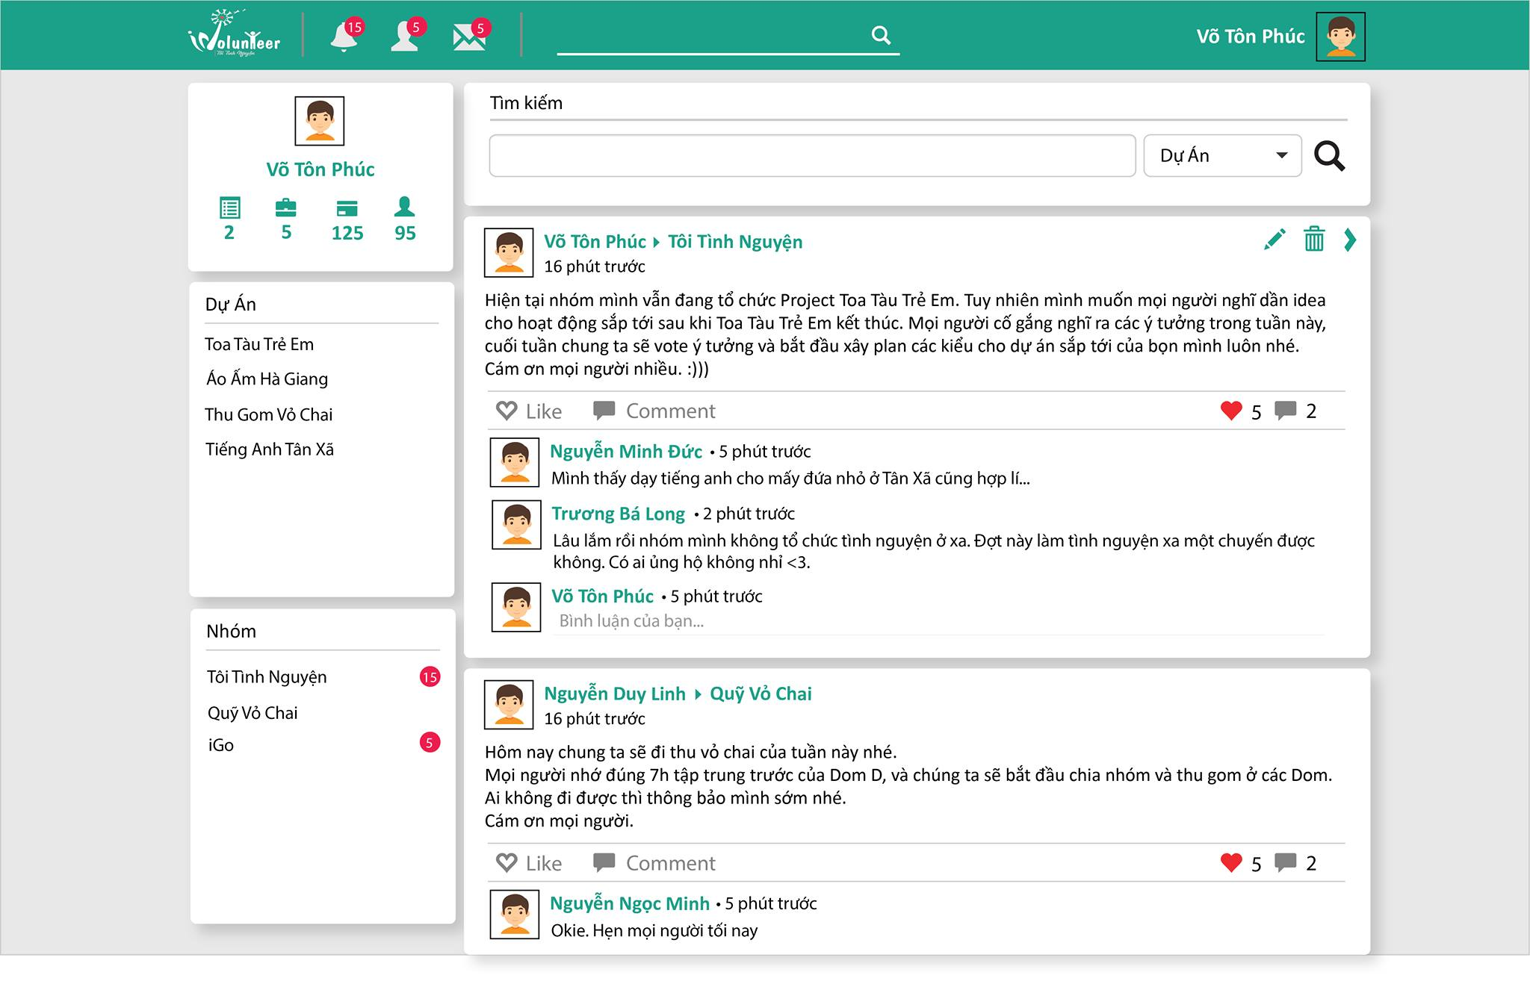

Figure ‑

|  |  |  |  |  |  |  |  |
| --- | --- | --- | --- | --- | --- | --- | --- |
| No | Field name | Field name in Vietnamese | Type | Require | Mandatory | Max-Length | Description |
| Navigation bar | | | | | | | |
| **1** | iVolunteer | Tôi tình nguyện | Link | Click | Y |  | Click to return to Home page. |
| **2** | Search |  | Text box | Type | Y |  | Get search value |
| **3** | Search |  | Button | Click | Y |  | Click to open Search Result page |
| **4** | User name |  | Link | Click | Y |  | Click to access user’s profile page |
| **5** | User profile picture |  | Thumb nail | Click | Y |  | Click to access user’s profile page |
| Profile card | | | | | | | |
| 6 | User profile picture |  | Thumb  nail | click | Y |  | Click to access to User Profile page |
| 7 | User name |  | Link |  | Y |  | Click to access to User Profile page |
| 8 | Project | Số project tham gia | Label |  | Y |  |  |
| 9 | Project count |  | Text |  | Y |  | Display total project that user has participated in. |
| 10 | Group | Số nhóm tham gia | Label |  | Y |  |  |
| 11 | Group count |  | Text |  | Y |  | Display total group that user has participated in. |
| 12 | Note | Số bài viết | Label |  | Y |  |  |
| 13 | Note count |  | Text |  | Y |  | Display total group that user has participated in. |
| 14 | Friend | số bạn bè | Label |  | Y |  |  |
| 15 | Friend count |  | Text |  | Y |  | Display total number of user’s friends. |
| Projects Panel | | | | | | | |
| 16 | Projects | Du an | Label |  | Y |  |  |
| 17 | Project item |  | Link | Click |  |  | Display projects name that user has participated in.  Click to open Project Home page. |
| 18 | Create Project | Lập dự án tình nguyện | Button | Click | Y |  | Click to open Project registration form |
| Groups Panel | | | | | | | |
| 19 | Groups |  | Label |  | Y |  |  |
| 20 | Group item |  | Link | Click |  |  | Display group name that user has participated in.  Click to open Group Home page. |
| 21 | Create Group | Lập nhóm tình nguyện | Button | Click | Y |  | Click to open Group registration form |
| Post in Group/Post in Project | | | | | | | |
| 22 | User profile  Image | Ảnh đại diện | Thumb  nail | Click | Y |  | Display User Profile picture  Click to access User profile page |
| 23 | User name | Tên user | Link | Click | Y |  | Display User name  Click to access User Profile page |
| 24 | Target name |  | Link | Click | Y |  | Display Group/Project name where this post was created. |
| 25 | Post time | Thời gian post | Text |  | Y |  | Display the time this post was created from now. |
| 26 | Edit | Sửa nội dung | Button |  | Y |  | Click to edit post content |
| 27 | Delete | Xóa post | Button |  | Y |  | Click to delete post |
| 28 | Post content | Nội dung post | Text |  | Y |  | Display post content |
| 29 | Like |  | Button |  | Y |  | Click to like post |
| 30 | Comment |  | Button |  | Y |  | Click to open comment box |
| 31 | Like number | Tổng số lượng like | Label |  | Y |  | Display total amount of |
| 32 | Comment number | Tổng số lượng comment | Label |  | Y |  |  |
| Comment box | | | | | | | |
| 33 | User profile image | Ảnh đại diện | Thumb  nail | Click | Y |  | Display User Profile picture  Click to access User profile page |
| 34 | User name | Tên user | Link | Click | Y |  | Display User name  Click to access User Profile page |
| 35 | Comment time | Thời gian comment | Text |  | Y |  | Display the time this comment was created from now. |
| 36 | Comment content | Nội dung comment | Text |  | Y |  | Display comment content |

Table ‑

## Profile

### Personal Information

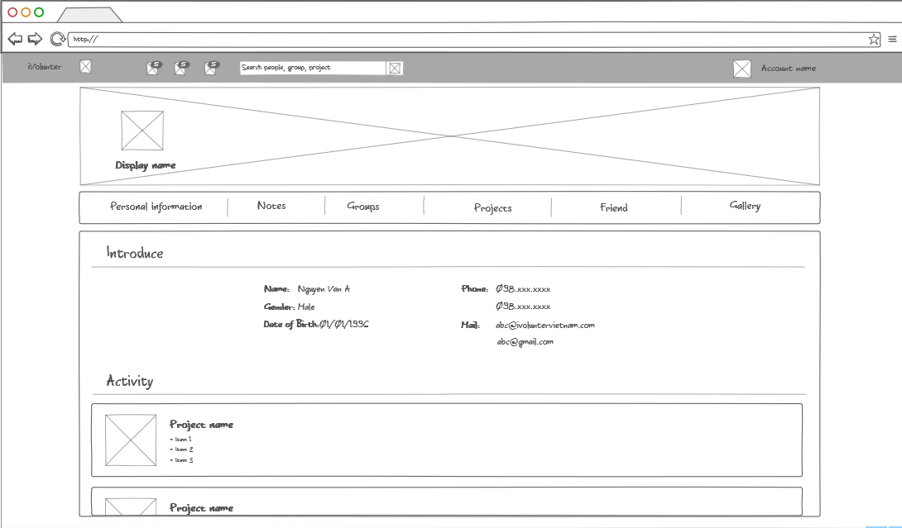

|  |  |  |  |  |  |  |  |
| --- | --- | --- | --- | --- | --- | --- | --- |
|  | Field name | Field name in Vietnamese | Type | Require | Mandatory | Max-Length | Description |
| Navigation bar | | | | | | | |
| Cover photo card | | | | | | | |
| **1** | Cover picture | Ảnh nền | Image | Click | Y |  | Display cover picture  Click to change cover picture |
| **2** | Profile picture | Ảnh đại diện | Image | Click | Y |  | Display profile picture  Click to change profile picture |
| Menu bar | | | | | | | |
| **3** | Personal information | Thông tin cá nhân | Button | Click | Y |  | Click to go to Personal information section |
| **4** | Notes | Nhật kí | Button | Click | Y |  | Click to go to Nots section |
| **5** | Groups | Nhóm tham gia | Button | Click | Y |  | Click to go to Groups section |
| **6** | Friends | Bạn bè | Button | Click | Y |  | Click to go to Friends section |
| Personal information | | | | | | | |
| **7** | Name | Họ và tên | Label |  | Y |  | Display name |
| **8** | Gender | Giới tính | Label |  | Y |  | Display gender |
| **9** | Date of birth | Ngày sinh | Label |  | Y |  | Display date of birth |
| **10** | Email | Địa chỉ Email | Label |  | Y |  | Display email |
| **11** | Update | Cập nhật | Button | Click | Y |  | Click to update information. |
| **12** |  |  |  |  |  |  |  |
| Activities | | | | | | | |
| **13** | Project profile image | Ảnh đại diện của project | Thumb  nail | Click | Y |  | Display project profile image  Click to access to Project home page. |
| **14** | Project name | Tên project | Link | Click | Y |  | Display project name  Click to access to Project home page. |
| **15** |  |  |  |  |  |  |  |

Table ‑

### Note

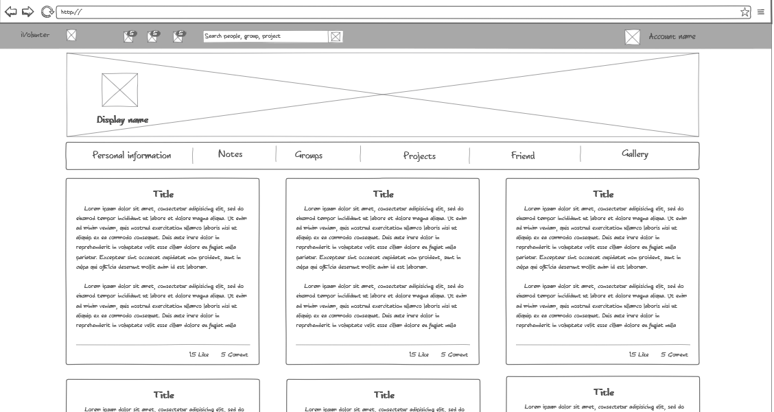

|  |  |  |  |  |  |  |  |
| --- | --- | --- | --- | --- | --- | --- | --- |
|  | Field name | Field name in Vietnamese | Type | Require | Mandatory | Max-Length | Description |
| Navigation bar | | | | | | | |
| Cover photo card | | | | | | | |
| Menu bar | | | | | | | |
| Note card | | | | | | | |
| 1 | Title | Tên nhật kí | Text |  | Y |  | Display note’s title |
| 2 | Brief note content | Vắn tắt nội dung | Text |  | Y |  | Display brief not content |
| 3 | Like count | Số lượng like | Label |  | Y |  | Display total like number |
| 4 | Comment count | Số lượng comment | label |  | Y |  | Display total comment |

Table ‑

### Group

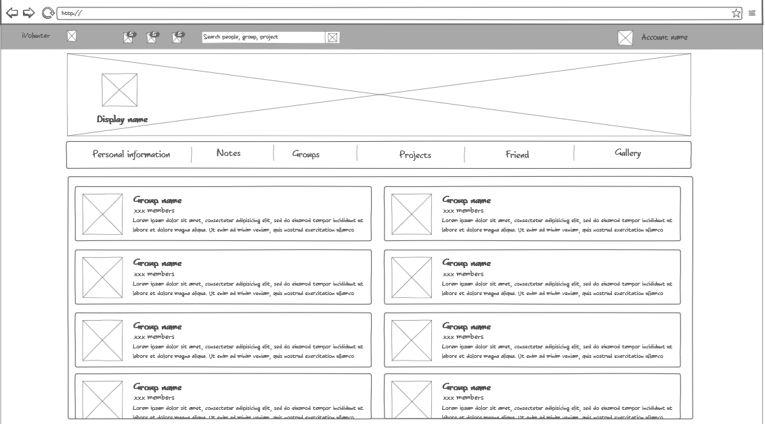

|  |  |  |  |  |  |  |  |
| --- | --- | --- | --- | --- | --- | --- | --- |
|  | Field name | Field name in Vietnamese | Type | Require | Mandatory | Max-Length | Description |
| Navigation bar | | | | | | | |
| Cover photo card | | | | | | | |
| Menu bar | | | | | | | |
| Group card | | | | | | | |
| **1** | Group profile picture | Ảnh đại diện Group | Thumb  nail | Click | Y |  | Display group profile picture Click to access Group Home page |
| 2 | Group name | Tên Group | Link | Click | Y |  | Display group name  Click to access Group Home page |

Table ‑

### Friend

### C:\Users\TamNV\Pictures\3.png

|  |  |  |  |  |  |  |  |
| --- | --- | --- | --- | --- | --- | --- | --- |
|  | Field name | Field name in Vietnamese | Type | Require | Mandatory | Max-Length | Description |
| Navigation bar | | | | | | | |
| Cover photo card | | | | | | | |
| Menu bar | | | | | | | |
| Friend card | | | | | | | |
| 1 | Cover picture | Anh nền | Image |  | Y |  | Display user cover picture |
| 2 | Profile picture | Ảnh đại diện | Image |  | Y |  | Display user profile picture |
| 3 | Name | Tên user | Link | Click | Y |  | Display user name  Click to access Friend’s profile page. |
| 4 | Unfriend | Hủy kết bạn | Button | Click | Y |  | Click to unfriend target user. |

Table ‑

## Project

### Public

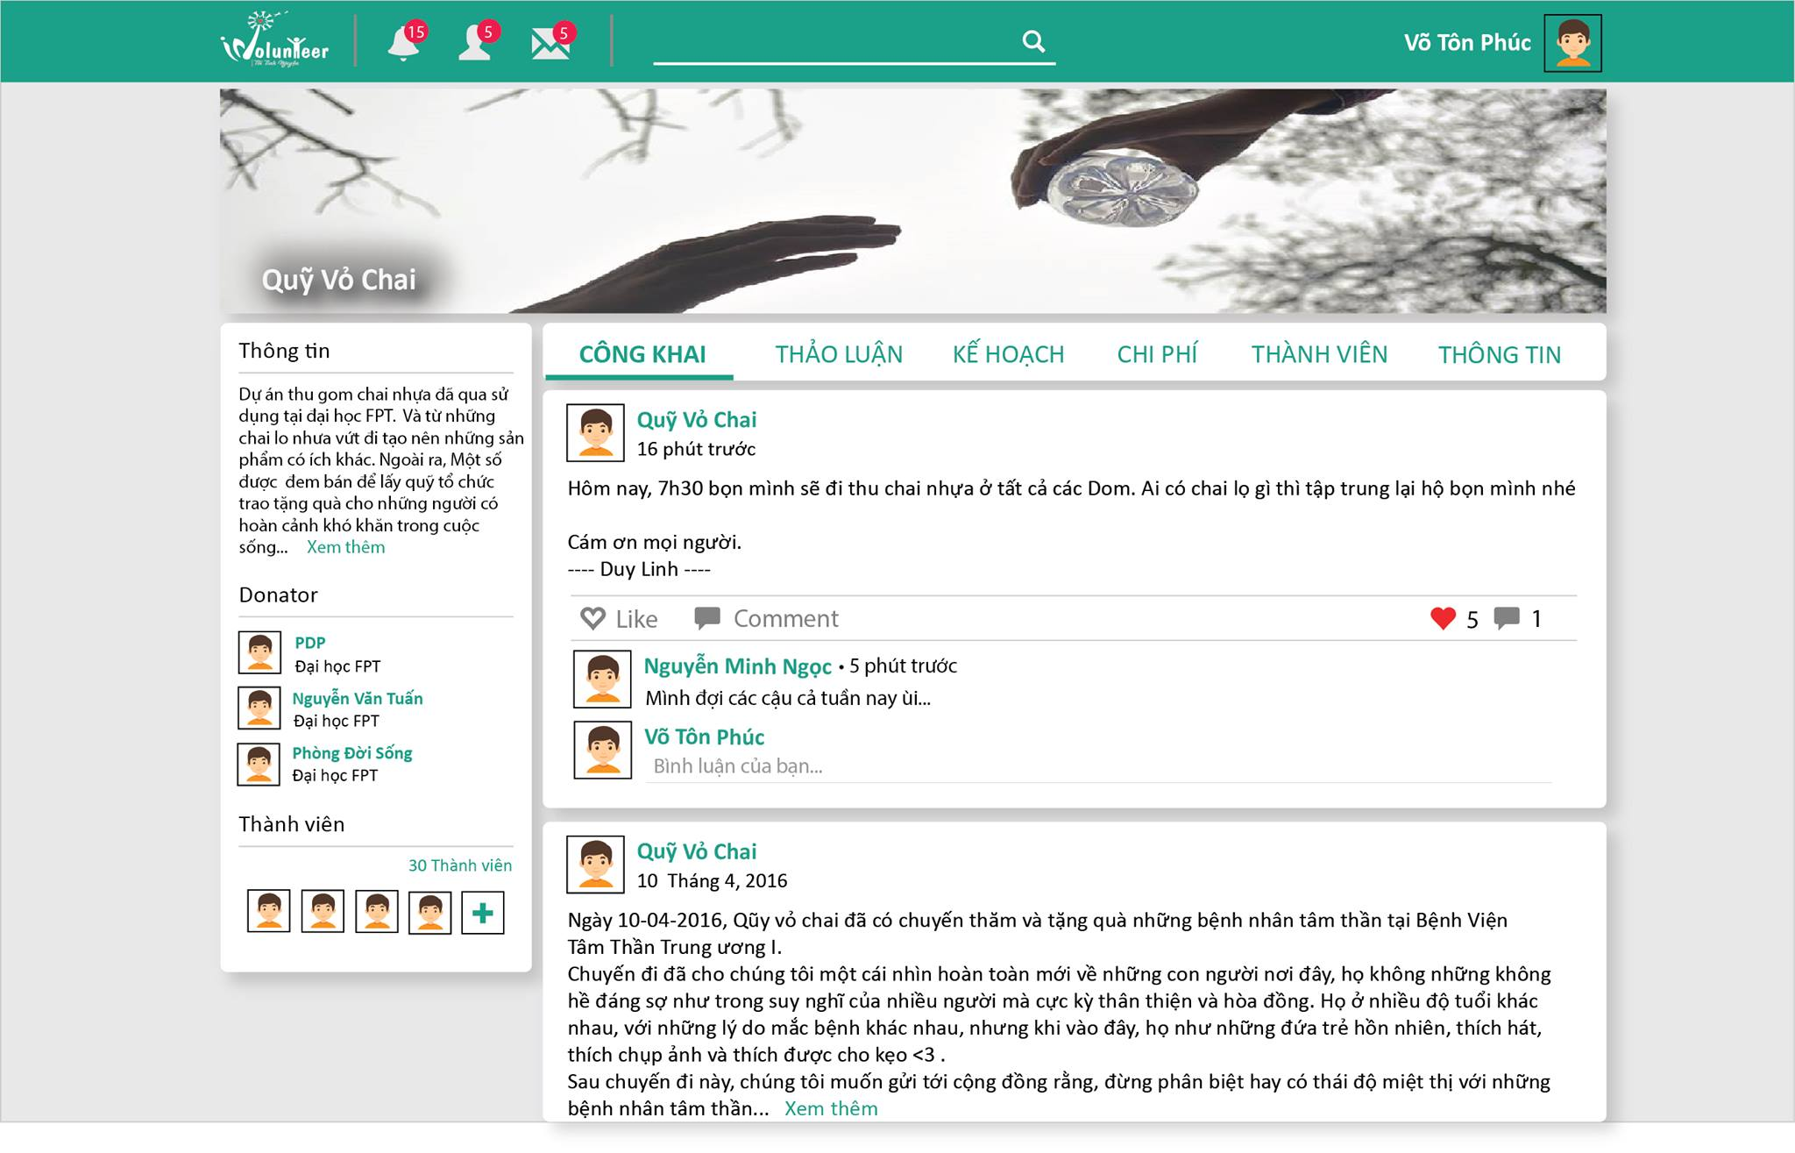

|  |  |  |  |  |  |  |  |
| --- | --- | --- | --- | --- | --- | --- | --- |
|  | Field name | Field name in Vietnamese | Type | Require | Mandatory | Max-Length | Description |
| Navigation bar | | | | | | | |
| Menu bar | | | | | | | |
| 1 | Public | Công khai | Button | Click | Y |  | Click to open Public section |
| 2 | Discussion | Thảo luận | Button | Click | Y |  | Click to open Discussion section |
| 3 | Planning | Kế hoạch | Button | Click | Y |  | Click to open Planning section |
| 4 | Budget | Chi phí | Button | Click | Y |  | Click to open Budget section |
| 5 | Members | Thành viên | Button | Click | Y |  | Click to open Members section |
| 6 | Information | Thông tin | Button | Click | Y |  | Click to open Information section |
| Post in Project | | | | | | | |
| Donators list | | | | | | | |
| 7 | User profile picture | Ảnh đại diện | Thumb nail |  | Y |  | Display user profile picture |
| 8 | User name | Tên user | Link | Click | Y |  | Display user’s name,  Click to access user profile page. |

Table ‑

### Discussion

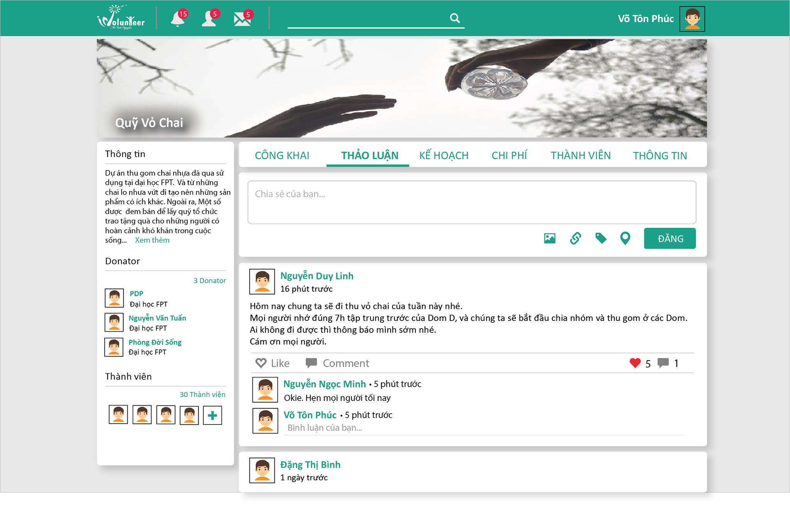

|  |  |  |  |  |  |  |  |
| --- | --- | --- | --- | --- | --- | --- | --- |
|  | Field name | Field name in Vietnamese | Type | Require | Mandatory | Max-Length | Description |
| Navigation bar | | | | | | | |
| Menu bar | | | | | | | |
| Discussion form | | | | | | | |
| 1 | Discussion content | Nội dung thảo luận | Text box | Type | Y |  | Get discussion value. |
| 2 | Attach Image | Chèn ảnh | Button | Click | Y |  | Click to attach image |
| 3 | Attach Link | Chèn link | Button | Click | Y |  | Click to attach link |
| 4 | Post | Đăng | Button | Click | Y |  | Click to post the discussion. |
| 5 |  |  |  |  |  |  |  |
| Post in Project | | | | | | | |

Table ‑

### Member

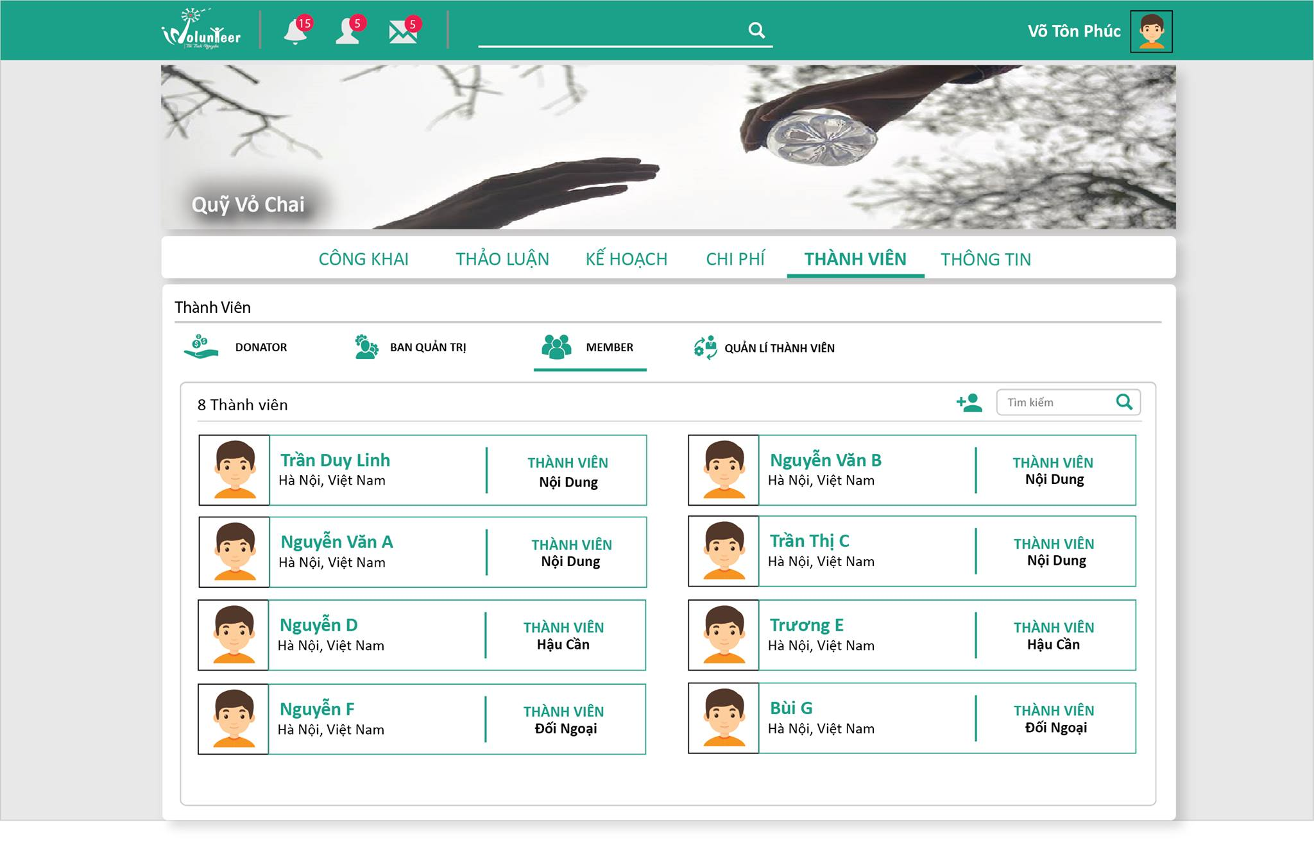

|  |  |  |  |  |  |  |  |
| --- | --- | --- | --- | --- | --- | --- | --- |
|  | Field name | Field name in Vietnamese | Type | Require | Mandatory | Max-Length | Description |
| Navigation bar | | | | | | | |
| Menu bar | | | | | | | |
| Member menu bar | | | | | | | |
| 1 | Donators | Danh sách nhà tài trợ | Button | Click | Y |  | Click to open Donators section |
| 2 | Leaders | Danh sách trưởng nhóm | Button | Click | Y |  | Click to open Leaders section |
| 3 | Members | Danh sách thành viên | Button | Click | Y |  | Click to open Members section |
| 4 | Member management | Quản lí thành viên | Button | Click | Y |  | Click to open Member management section |
| Post in Project | | | | | | | |

Table ‑

### Information

## Search

### Project

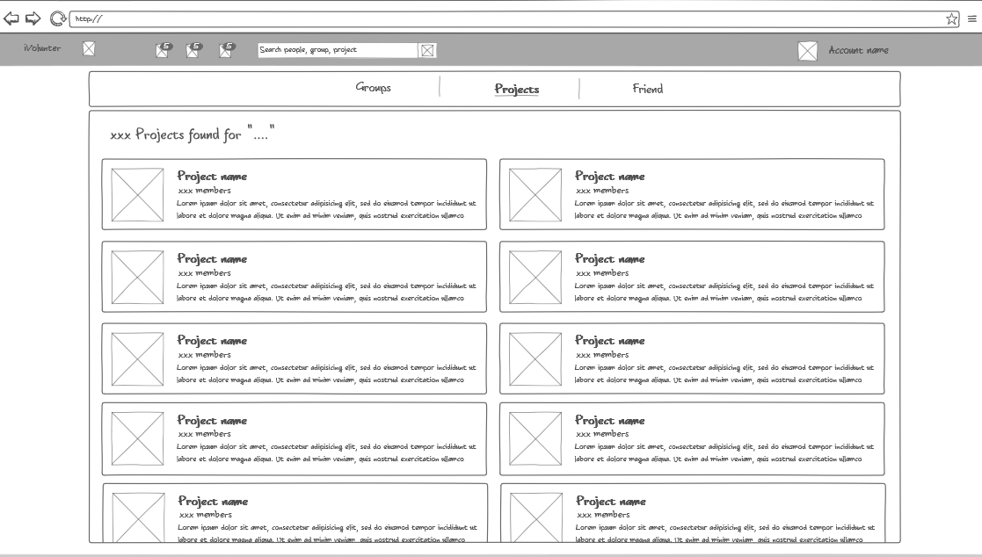

|  |  |  |  |  |  |  |  |
| --- | --- | --- | --- | --- | --- | --- | --- |
|  | Field name | Field name in Vietnamese | Type | Require | Mandatory | Max-Length | Description |
| Navigation bar | | | | | | | |
| Search Menu bar | | | | | | | |
| 1 | Groups | Nhóm | Button | Click | Y |  | Click to open Groups result section |
| 2 | Projects | Dự án | Button | Click | Y |  | Click to open Projects result section |
| 3 | User | Người dùng | Button | Click | Y |  | Click to open Users result section |
| Projects result section | | | | | | | |
| 4 | Project profile picture | Ảnh đại diện Project | Thumb  nail | Click | Y |  | Display group profile picture Click to access Project Home page |
| 5 | Project name | Tên Project | Link | Click | Y |  | Display group name  Click to access Project Home page |

Table ‑

### Group

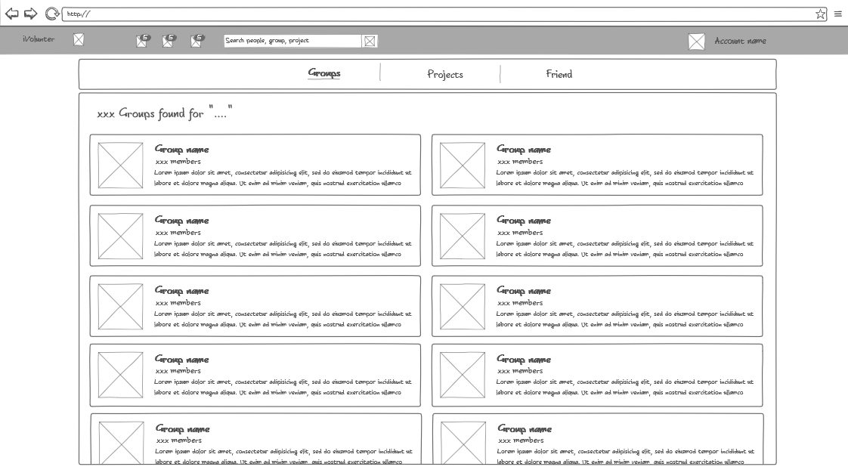

|  |  |  |  |  |  |  |  |
| --- | --- | --- | --- | --- | --- | --- | --- |
|  | Field name | Field name in Vietnamese | Type | Require | Mandatory | Max-Length | Description |
| Navigation bar | | | | | | | |
| Search Menu bar | | | | | | | |
| Groups result section | | | | | | | |
| 1 | Group profile picture | Ảnh đại diện Group | Thumb  nail | Click | Y |  | Display group profile picture Click to access Group Home page |
| 2 | Group name | Tên Group | Link | Click | Y |  | Display group name  Click to access Group Home page |

Table ‑

### User

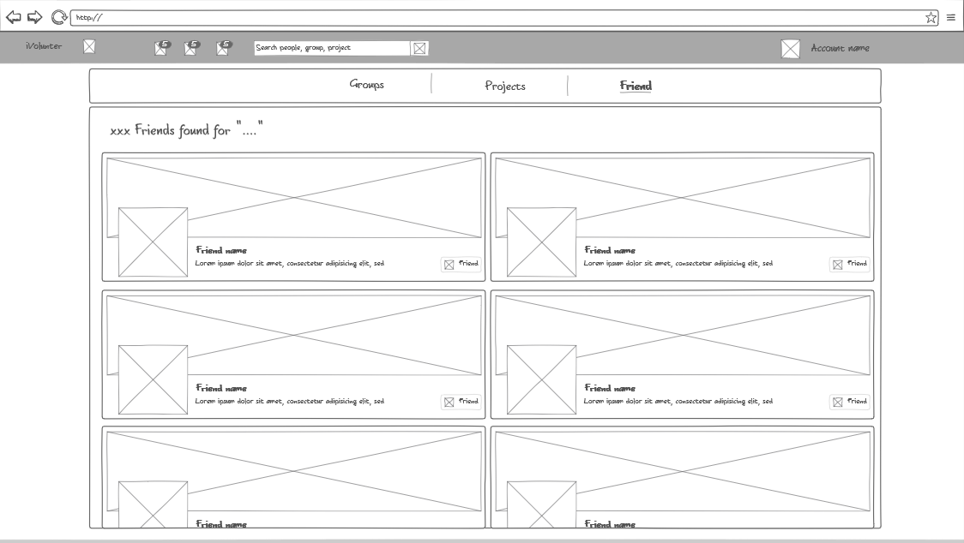

|  |  |  |  |  |  |  |  |
| --- | --- | --- | --- | --- | --- | --- | --- |
|  | Field name | Field name in Vietnamese | Type | Require | Mandatory | Max-Length | Description |
| Navigation bar | | | | | | | |
| Search Menu bar | | | | | | | |
| Friends result section | | | | | | | |
| 1 | Cover picture | Anh nền | Image |  | Y |  | Display user cover picture |
| 2 | Profile picture | Ảnh đại diện | Image |  | Y |  | Display user profile picture |
| 3 | Name | Tên user | Link | Click | Y |  | Display user name  Click to access Friend’s profile page. |
|  |  |  |  |  |  |  |  |

Table ‑